**Assignment Questions on Digital Marketing**

1. Create a blog or website using BlogSpot and Word Press. Customize the theme design and post new article with 500 words.

<https://www.blogger.com/blog/posts/6542387029289941789>

2. Create a new facebook Business page and post one social media poster using canva.

<https://www.facebook.com/share/W2tgFK2hEoPL9whW/?mibextid=xfxF2i>

3. Create and design a social media advertisement poster using canva.

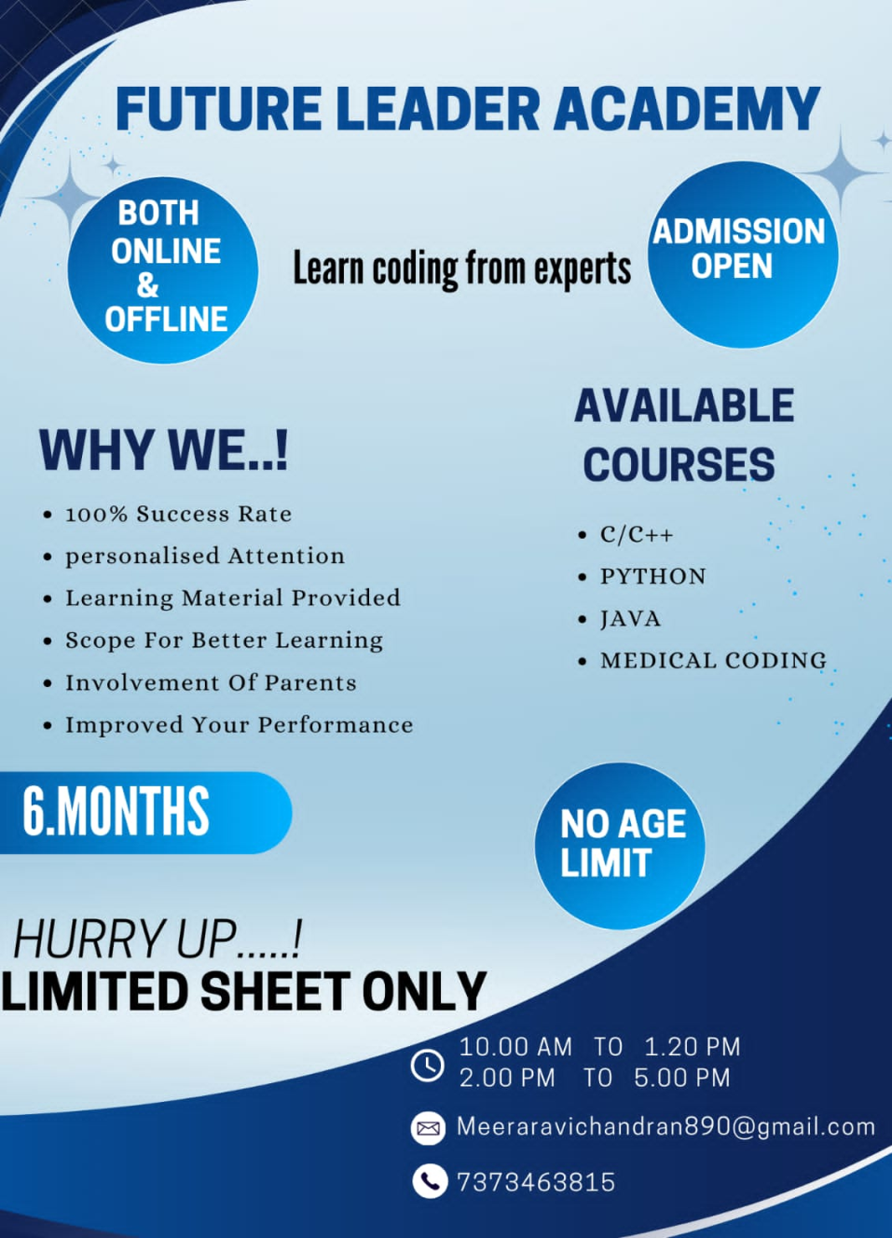

4. Create email newsletter design using Mailchimp or canva tool.

